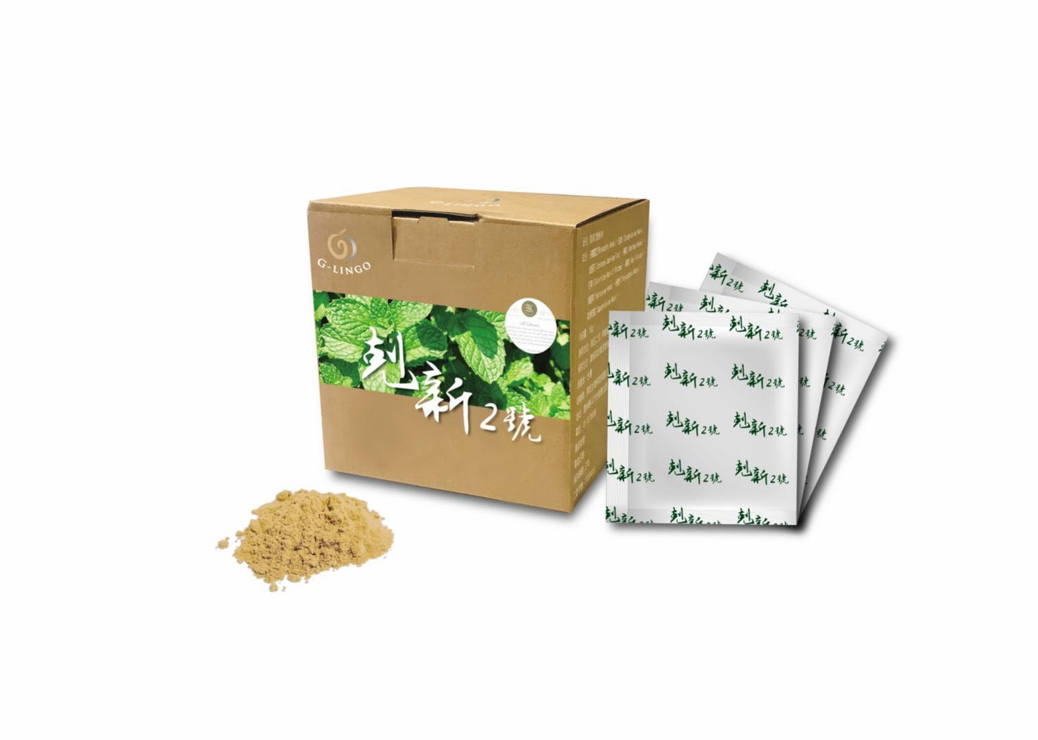
剋 新 2 號
主成分：
白鶴靈芝萃取物、玄參萃取物、金銀花萃取物、薄荷萃取物、甘草萃取物、桔梗萃取物、魚腥草萃取物、桑葉萃取物、栝樓根萃取物、美洲防風。
Main ingredients:
Rhinacanthi Herba、Scrophulariae Radix、Lonicerae Japonicae Flos、Menthae Herba
、Glycyrrhizae Radix et Rhizoma、Platycodonis Radix、Houttuyniae Herba、Mori Folium
、Trichosanthis Radix、Saposhnikoviae Radix。

草本預防肺炎配方/成分天然加倍健康
Herbal Prescription to prevent pneumonia/Be more healthy with natural ingredients

白鶴靈芝(Rhinacanthi Herba )
白鶴靈芝性涼味甘美芳香，主入肺、肝、胃、大小腸諸經，有降火、潤肝、清肺熱咳嗽、消炎解毒、肝炎、胃炎、糖尿病等功效。含有仙鶴草分A、B、C、D、E,木犀草素-7-葡萄糖苷等成分。
Rhinacanthi Herba
Rhinacanthi Herba is cool-natured with a sweet taste and aromatic smell. It primarily affects the lung, liver, stomach, and large and small intestine meridians and has effects including to reduce internal heat, nourish the liver, clear lung heat and cough, act as anti-inflammatory and detoxification, and treat hepatitis, gastritis, and diabetes. It contains ingredients such as Agrimonia Pilosa Ledeb A, B, C, D, E, and Luteolin-7-glucoside.

玄參（Scrophulariae Radix）
玄參用於咽喉腫痛、瘰癧痰核、癰腫瘡毒。現代研究指出玄參有擴張血管，促進局部血液循環而有消除炎症的作用。
Scrophulariae Radix
Scrophulariae Radix is used to treat throat swelling and soreness, lymphadenopathy, and carbuncle. Modern research has pointed out that Scrophulariae Radix can dilate blood vessels to promote localized circulation to achieve anti-inflammatory effects

金銀花（Lonicerae Japonicae Flos）
金銀花能清熱解毒，疏散風熱。於現代研究中發現其具有廣效抗菌作用，對流感病毒及致病黴菌等多種病原亦有抑制作用。在臨床症狀上有明顯抗炎及解熱作用。
Lonicerae Japonicae Flos
The Lonicerae Japonicae Flos can clear heat and detoxify, and dispel wind heat. Modern research has found that it has a broad spectrum antibacterial effect, and has inhibitory effects on multiple pathogens, including the influenza virus and pathogenic fungi. It has significant anti-inflammatory and antipyretic effect on clinical symptoms.

薄荷（Menthae Herba）
薄荷可用於頭痛目赤，咽喉腫痛。義大利人稱薄荷為「聖母草」，其具有消炎抗菌、健胃祛風的作用，對上呼吸道感染亦有明顯的止咳、消炎和抑菌，現代研究指出薄荷萃取物具有抑制新冠肺炎病毒之潛力。
Menthae Herba
The Menthae Herba can be used to treat headache, conjunctivitis, and throat swelling and soreness. Italians call Menthae Herba “Mary’s Mint”. It has anti-inflammatory and antibacterial effects, and invigorates the stomach, and expels wind. It has significant antitussive, anti-inflammatory, and bacteriostatic effects when used to treat upper respiratory tract infections.

甘草（Glycyrrhizae Radix et Rhizoma）
甘草益氣補中、清熱解毒、祛痰止咳、緩急止痛、調和藥性。於現代醫學中，甘草有類似腎上腺皮質激素樣作用，有抗炎、抗過敏作用，能保護發炎的咽喉和氣管的粘膜。
Glycyrrhizae Radix Et Rhizoma
The Glycyrrhizae Radix Et Rhizoma invigorates the spleen and replenishes qi, clears heat and detoxifies, clears sputum and prevents cough, relieves pain and spasm, and regulates nature of other medicine being used. In modern medicine, Glycyrrhizae Radix Et Rhizoma has a cortisol-like anti-inflammatory and anti-allergy effect and protects against inflammation of the throat and tracheal mucosa.

桔梗（Platycodonis Radix）
桔梗宣肺化痰、利咽、排膿。現今研究指出桔梗能稀釋痰液，而有較強的祛痰作用，並有鎮咳作用。此外桔梗含桔梗皂甙，其有抗炎作用。
Platycodonis Radix
The Platycodonis Radix clears the lungs and eliminates sputum, relieves sore throat, and clears pus. Modern research has pointed out that Platycodonis Radix can dilute sputum, has a strong effect against clearing sputum, and also has antitussive effects. In addition, Platycodonis Radix contains Platycodin, which has anti-inflammatory effects.

魚腥草（Houttuyniae Herba）
魚腥草用於肺癰吐膿，肺熱咳嗽。因魚腥草含多種保健功效，日本人稱其為「十藥」。現代藥理學發現，魚腥草素有抑菌、抗發炎效果，因此也被稱為「中藥裡的抗生素」。其臨床上主要將魚腥草用於治療感染、發炎症狀，如呼吸道感染、結膜炎、急慢性鼻竇炎、病毒性腸炎等症狀。
Houttuyniae Herba
The Houttuyniae Herba is used to treat suppurative lung diseases and dispel pus, and also treats lung-heat and coughs. The Japanese call it the “ten medicines” for its multiple beneficial health effects. Modern pharmacology has found that Houttuyniae herba has bacteriostatic and anti-inflammatory effects, which is why it is also called the “antibiotic of Chinese medicine”. Clinically, Houttuyniae Herba is used to treat infections and inflammatory symptoms such as respiratory tract infections, conjunctivitis, acute and chronic sinusitis, and viral gastroenteritis.

桑葉（Mori Folium）
桑葉桑葉能入肺肝經，有疏風清熱、潤肺止咳之功。於現代研究中，桑葉含皮固醇、芸香甙、桑甙、懈皮素、異懈皮素、東茛菪甙等，體外試驗也指出鮮桑葉煎劑能對金黃色葡萄球菌、乙型溶血性鏈球菌、鉤端螺旋體等多種致病菌有抑制作用。
Mori Folium
The Mori Folium affects the lung and liver meridians, and can dispel wind and clear heat, invigorate the lung, and prevent cough. Modern research has found that Mori Folium contains contents of corticosteroid, rutin, morusin, quercetin, isoquercetin, and scopolin. In vitro trials have pointed out that fresh Mori Folium decoctions has inhibitory effects against multiple pathogens, such as the Staphylococcus Aureus, Beta-hemolytic Streptococcus, Leptospira, etc.

栝樓根（Trichosanthis Radix）
栝樓根能清肺熱而潤肺燥，其含有糖類化合物（天花粉多醣），現代藥理學發現具有明顯的免疫調節作用，能增強免疫活性，也具有顯著的抗腫瘤能力。
Trichosanthis Radix
The Trichosanthis Radix can clear lung heat and nourish and moisten the lung. It contains carbohydrates (trichosanthes polysaccharide). Modern pharmacology has found that it has significant immunomodulatory effects, can increase immune activity, and has significant anti-neoplasm effects.

美洲防風（Saposhnikoviae Radix）
美洲防風主要含色酮類成分（升麻素,升麻素苷）、香豆素類成分（香柑內酯），具有解熱、鎮痛、抗炎、抗過敏、抗腫瘤、抗氧化、調節免疫及抗凝血等作用。
Saposhnikoviae Radix
The Saposhnikoviae Radix primarily contains chromone type ingredients (Cimicifuga, Cimicifuga Glycoside) and coumarin type ingredients (bergapten). It has antipyretic, analgesic, anti-inflammatory, anti-allergic, anti-neoplastic, antioxidant, immunomodulatory, and anti-coagulation effects.

新冠肺炎(COVID-19)致病機轉三階段
Three Stages for Pathogenic Mechanism of COVID-19

第一階段：
無症狀期(感染後前1-2天)
吸入病毒後，病毒先附著於鼻腔上皮細胞，並開始複製ACE2(為病毒的表面受體)。此時身體產生的先天性免疫反應仍有限。在此階段，病毒可藉由nasal swabs被偵測。
Stage 1:
Asymptomatic Phase (1-2 days after infection)
After inhaling the virus, the virus particle attaches to the epithelial cells in the nasal cavity and begins to replicate ACE2 (the virus’s surface receptor). During this time, there is limited innate immune reaction generated by the body. The virus can be detected by nasal swabs during this stage.

第二階段：
呼吸道症狀期(第一階段後幾天)
病原開始沿著呼吸道向下移行，此時身體開始引發強大的先天性免疫反應，CXCL10或其他cytokine將可被偵測，此外感染病毒的臨床症狀將會出現。在此階段，病患需密集監控，病毒可藉由nasal swabs或痰液被偵測，約有80%的病患症狀輕微並侷限在上呼吸道、氣管及支氣管。
Stage 2:
Respiratory tract symptoms phase (a few days after stage 1)
The pathogen begins to migrate down the respiratory tract, and by this time, the body will have generated a large innate immune reaction. CXCL10 and other cytokines can be detected, and clinical symptoms from the virus infection will appear. During this stage, the patient must be closely monitored. The virus can be detected from nasal swabs or the sputum, and about 80% of patients will only experience mild symptoms limited to the upper respiratory tract, the trachea, and bronchi.

第三階段：
出現缺氧、玻璃樣浸潤(Ground glass infiltrates)並發展至急性呼吸窘迫症候群(Acute respiratory distress syndrome, ARDS)
將會有約20%患者進入到第三階段，其致死率初估為2%，但依年齡而有所不同。此時期病毒已浸潤到肺部，主要感染第二型肺泡上皮細胞使其細胞凋亡，釋放出大量病毒。治癒後，會產生比普通的ARDS有更嚴重的纖維化及斑疤組織。
Stage 3:
Hypoxia, ground glass infiltrates, and development towards acute respiratory distress syndrome (ARDS)
About 20% of patients will reach stage 3, and the virus’s mortality rate is approximately 2%, varying according to age. At this stage, the virus will have infiltrated into the lungs, and it primarily infects type II alveolar epithelial cells and causes cell apoptosis, which in turn releases a great amount of virus. After the patient has recovered from the disease, their lungs would suffer from fibrosis and scar tissues, which are more severe than the general ARDS.
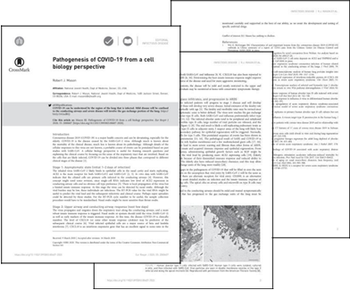

剋新二號的特殊成分能有效讓患者改善在該階段症狀，此原料亦能製成保健食品讓廣大民眾使用，充分達到預防勝於治療。
The specific ingredients of COVID No. 1 can effectively help patients improve the symptoms of the corresponding stage. The raw ingredients can also be made into health supplements available to the general public and achieving prevention over treatment.

以下是漢聖製藥的基礎資質及專利簡介
The following is Han Sheng Pharmaceutical’s general qualifications and patent information
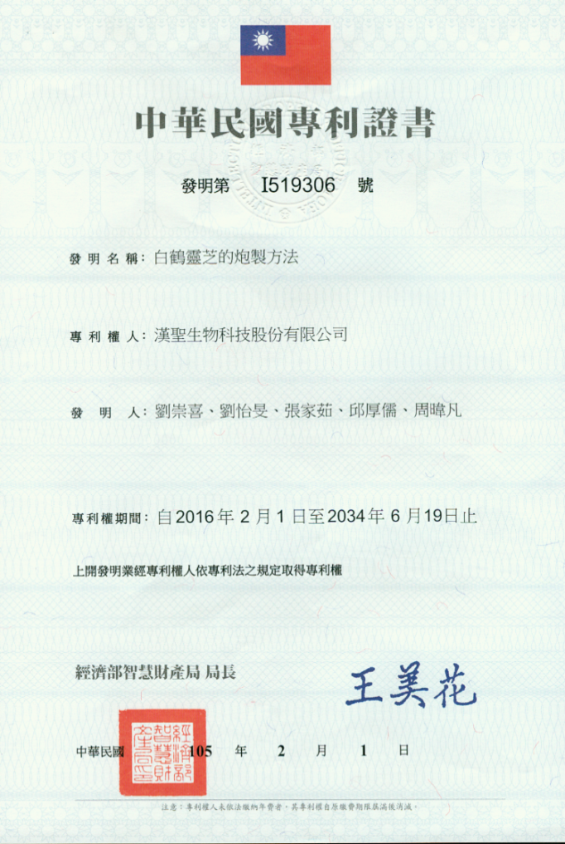
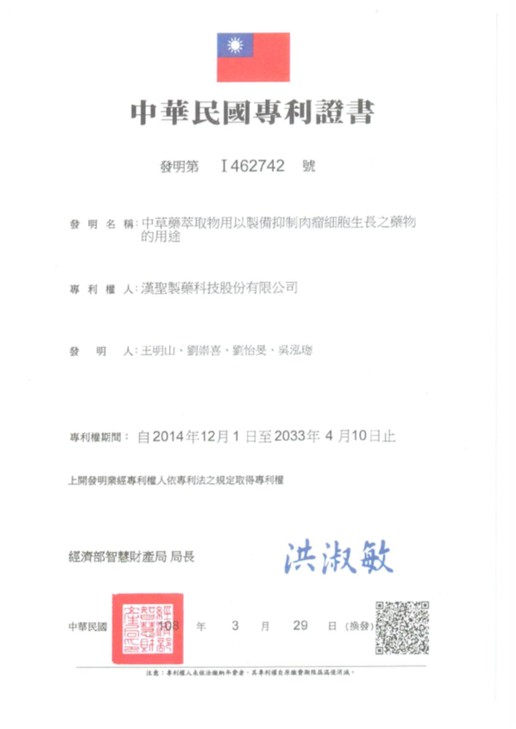

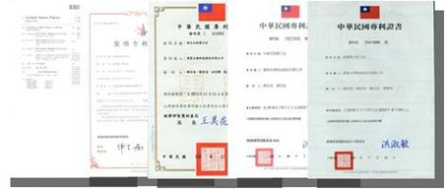
GMP 製藥廠嚴謹的安全品質管控
Strict GMP Pharmaceutical Safety and Quality Control

堅持 GAP 優良的農業規範/漢聖製藥看重產品原料的質量與安全專業技術
We adhere to the GAP (Good Agricultural Practices)/Han Sheng Pharmaceutical values the quality of the product’s raw materials and the safety of expertise
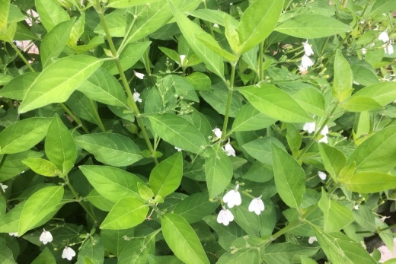

白鶴靈芝(Rhinacanthus nasutus (L.) Kurz)植物圖

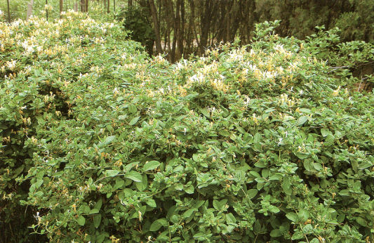
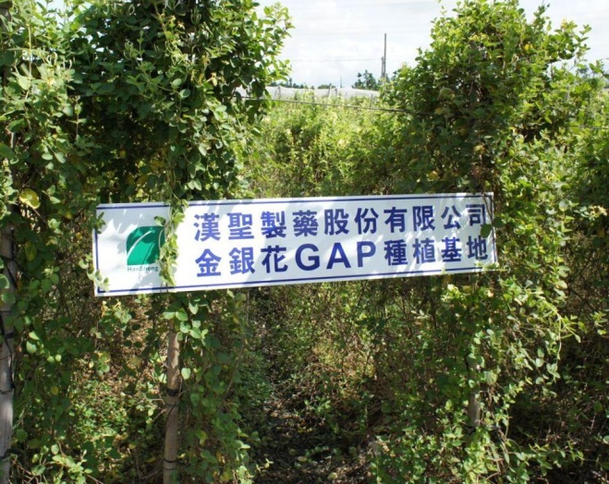

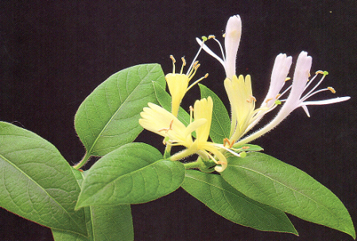
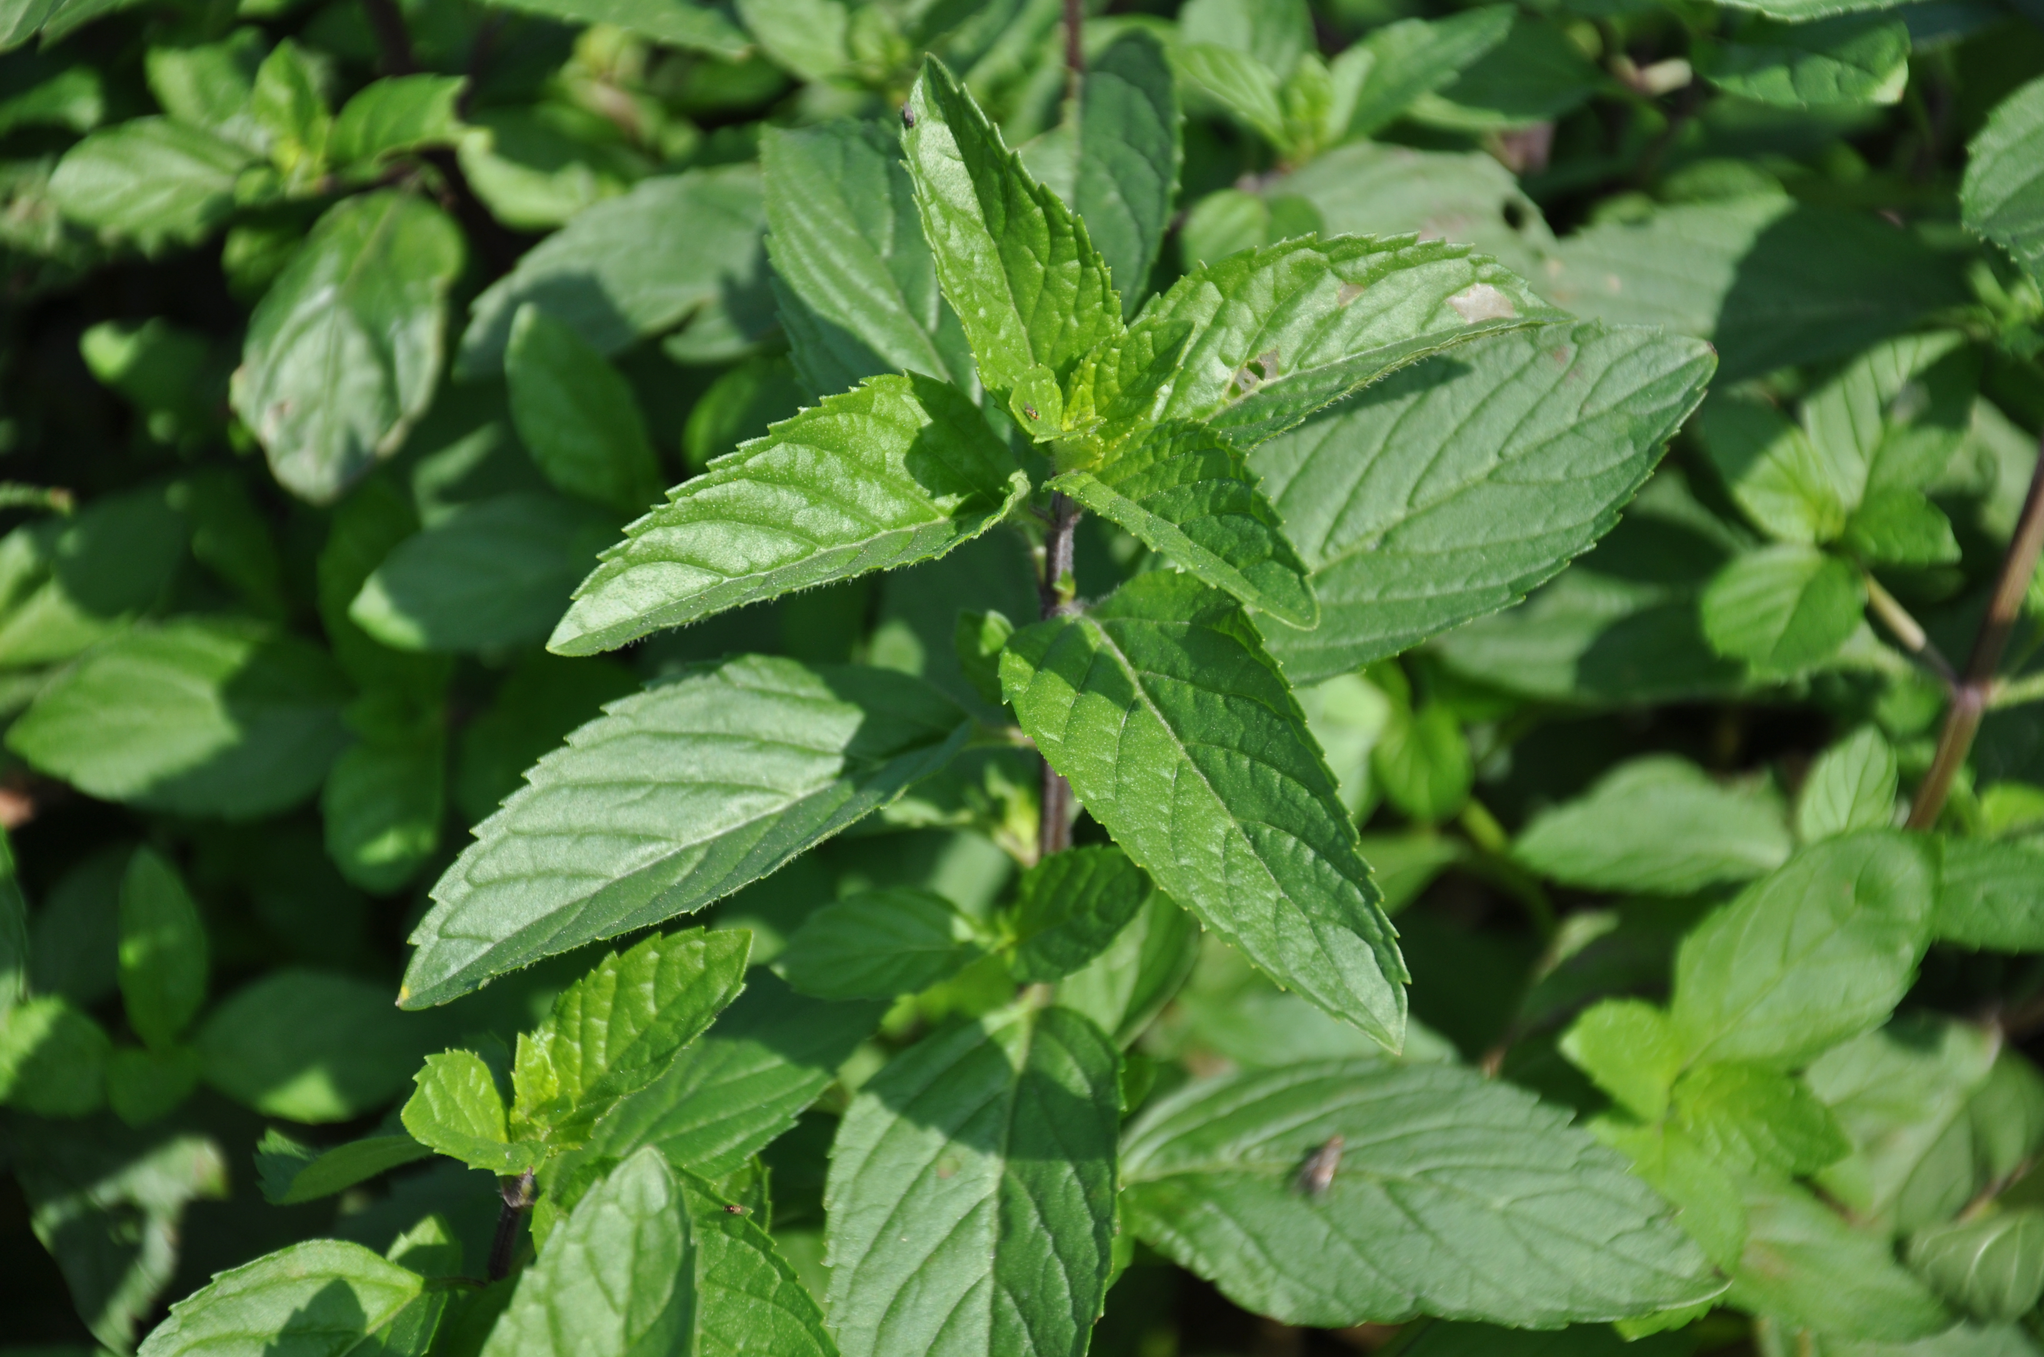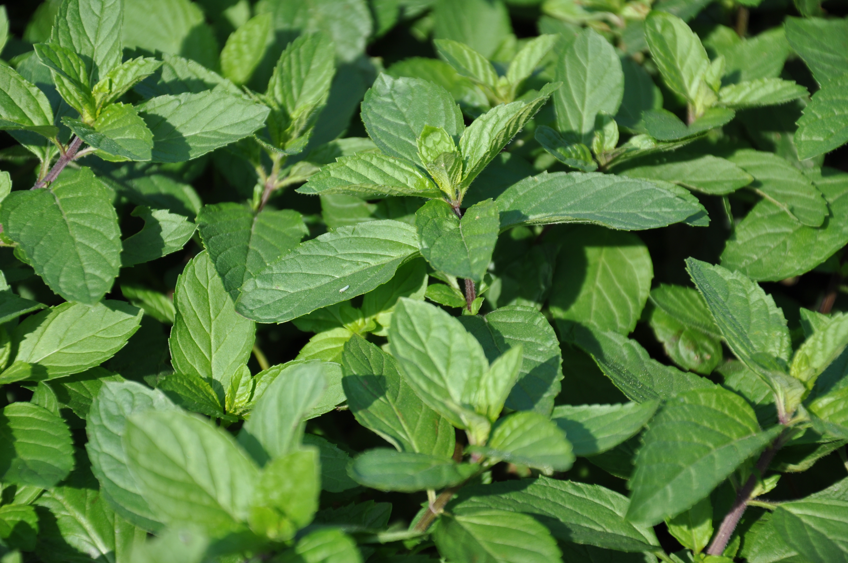
金銀花(Lonicera japonica Thunb.)植物圖

薄荷(Mentha haplocalyx Briq.)植物圖
- 炮製技術
遵循古法炮製，依食材添加輔料增加食材有效成分釋出、改變食材性質、減少副作用，以提升消費者的食品安全（美國專利證書 US 9,533,018 B2、中華人民共和國專利第 3398199 號、中華民國專利第Ⅰ551292 號、中華民國專利第Ⅰ414303 號）
1. Brewing Technique
We follow the traditional brewing technique by adding adjuvants to the ingredients to increase the release of active ingredients, alter the ingredient’s nature, decrease side effects, and ultimately increase the consumer’s food safety (US Patent Certificate No. 9,533,018 B2, People’s Republic of China Patent No. 3398199, Republic of China Patent No. I 551292, Republic of China Patent No. I 414303)

- 萃取濃縮
利用現代高科技、高效率的技術萃取有效成分，以低溫濃縮方式確保活性成分不被破壞
2. Extract Concentration
We use advanced and effective modern technology to extract the active ingredients and uses cryoconcentration to ensure that the active ingredients are not damaged

- 指標成分分析
透過專利特殊技術分析炮製萃取物活性物質和指標成分，作為配方調劑篩選基礎（中華民國專利第Ⅰ541496 號）
專業研發、配方調製。依食品的預設配方，進行配方試驗，透過現代高科技炮製濃縮萃取技術，高效率萃取有效成分（中華民國專利第Ⅰ 406669 號、中華民國專利第Ⅰ 414303 號、美國專利證書 US 8,420,136 B2、中華民國專利第 M 445981 號、中華民國專利第Ⅰ 379687 號、中華人民共和國專利第 2628188 號、中華人民共和國專利第 2544155 號、中華民國專利第 M 425668 號）
3. Marker Ingredient Analysis
The patented special technology was used to analyze the brewed extracts of active constituents and marker ingredients to be used as a screening basis for professional research and development and prescription preparation (Republic of China Patent No. I 541496). The default prescription for the foodstuff was tested for formula experiment using advanced modern brewing, concentrating, and extracting technique to extract the active ingredients with high efficiency (Republic of China Patent No. I 406669, Republic of China Patent No. I 414303, US Patent Certificate No. 8,420,136 B2, Republic of China Patent No. M 445981, Republic of China Patent No. I 379687, People’s Republic of China Patent No. 2628188, People’s Republic of China Patent No. 2544155, Republic of China Patent No. M 425668).

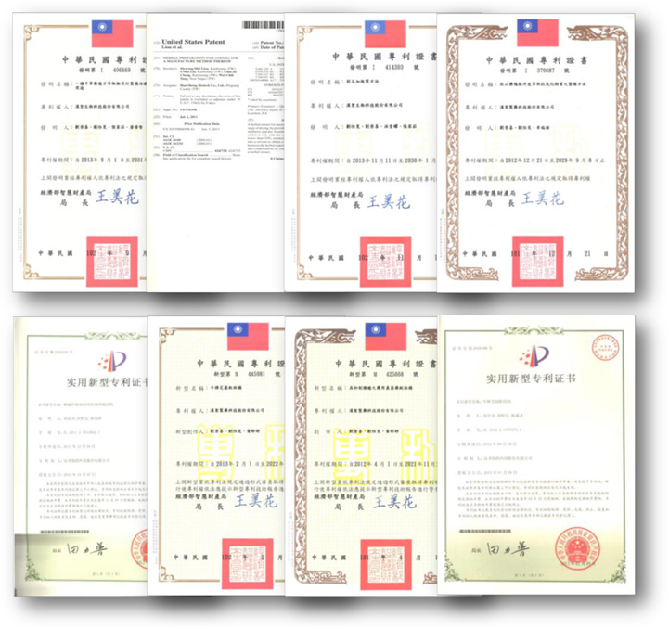

檢 驗 報 告
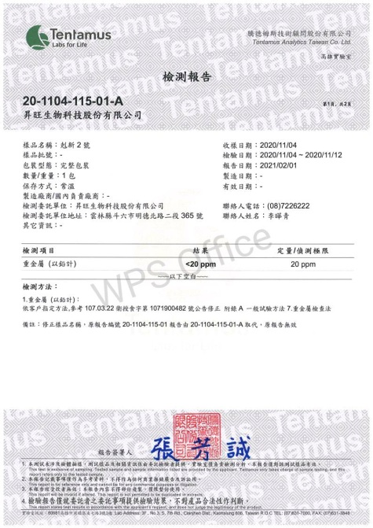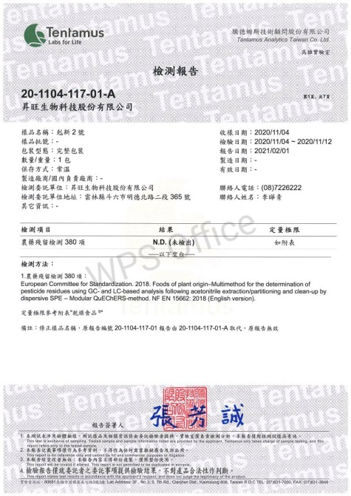

炮製濃縮萃取技術
漢承生物科技股份有限公司
Brewing, Concentrating, and Extracting Technology
Han Cheng Biotech Co., Ltd.

製作單位
GMP 漢聖製藥科技股份有限公司
Producer
GMP Han Sheng Pharmaceutical Technology Co., Ltd.

